**Displaying Pokemon Stats as a Hexagonal Graph or Bar Graph**

**By Fernando G. Berry**

The basic formula for determining the length of an element or distance of a point from center is:

$S_{base}÷S_{max}*D$

Where $S_{base}$ is the base stat of a pokemon, $S_{max}$ is the maximum possible stat value, and $D$ is the maximum available distance of a given element or chart.

For a bar chart, this is all that is really needed to calculate as $D$ can just represent an element height or width.

A hexagonal chart is different as the distance represents a vector from the center of the chart to the maximal point that is $60°$ from a reference angle.

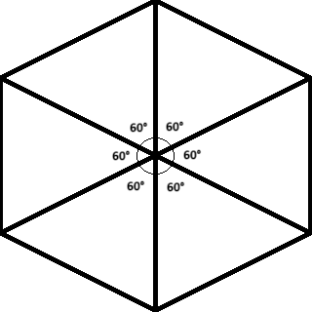

The solution of this problem is to use the trigonometric functions of $sin()$ and $cos()$ to find the $opposite$ and $adjacent$ of a given $hypotenuse$ equaling $D$.

$opposite =sin(Θ) * D$

&

$adjacent =cos(Θ) * D$

We can then define the $opposite,adjacent$ as the $x,y$ coordinate and apply an offset to re-zero the point of origin (PO) to the center of a drawing screen. A - $30°$ offset will be applied to each angle since angles are being referenced to a cartesian coordinate system.

A function will be invoked to perform the required mathematics and return a pair of coordinates based off of angle, distance, and PO arguments. This function will ignore the $sin()$ and $cos()$ processing of $±90°$ angles. It will instead treat the distance as the $y$ coordinate. An inversion of the $y$ coordinate will be required for angles greater than $180°$. All angles provided as arguments are expected to be $30°,90°,150°,210°,270°, or 330°$ after the angle offset is provided.

The function is expected to behave as follows:

**Declare Function** getCoordinate( **number** angle, **number** distance, **array** offset )

**Declare array** coordinate and **assign** an **array** with indices 0 and 1 set to 0

**Check if number** angle > 180 degrees

**true: assign number** distance = negative **number** distance

**false:** continue

**Check if number** angle is 90 **or** 270 degrees

**true: assign array** coordinate index 1 = negative **number** distance

**false:**

**assign array** coordinate index 0 = **sin**(**number** angle) * **number** distance

**assign array** coordinate index 1 = **cos**(**number** angle) * **number** distance

**assign** **array** coordinate index 0 = **array** coordinate index 0 - **array** offset index 1

**assign** **array** coordinate index 1 = **array** coordinate index 1 - **array** offset index 1

**return array** coordinate

**End of Function**